

ASSESSMENT, REPORTING
& FEEDBACK POLICY

Policy adopted by the Governing Body of The Wordsley School

Date adopted by the Governing Body | 25th June 2025
Signed by the Chair of Governors | N Hubbard
1. Introduction  Contents | 3
2. Purpose of assessment | 3
3. Principles of assessment | 3
4. Expected practice in summative assessment | 4
5. School data collection | 5
6. Our Feedback Policy | 6
7. Quality Assuring Assessment and Feedback | 8
8. Training and Support | 8
9. Inclusion | 9
10. Roles and responsibilities | 9
11. Links with other policies | 9

Appendices
Appendix 1 – The Wordsley Way – Marking and Feedback – Policy into Practice | 10
Appendix 2 – Presentation Guide | 11
Appendix 3 – Examples of WWW and Grow targets | 12
Appendix 4 – Whole Class Feedback Sheet | 13
Appendix 5 – Literacy Codes and spelling grid | 14

1. Introduction

The aim of this policy is to:
- Provide clear guidelines on our approach to formative and summative assessment
- Establish a consistent and coherent approach to recording summative assessment outcomes and reporting to parents/carers
- Clearly set out how and when assessment practice will be monitored and evaluated

Effective assessment and feedback is an essential part of the education process and is crucial in advancing pupil progress and outcomes. It is recognised that teachers will develop a wide range of assessment techniques to support their pedagogy and that assessment will vary according to the subject being taught and the age range of the pupils.
Parents, Governors and other stakeholders need to be informed about the progress that pupils are making.

2. Purpose of assessment
The purpose of high quality assessment and feedback at The Wordsley School is to:
- Help pupils to know and understand where their strengths are and what they can do to improve. Pupils should be able to articulate what they are doing well and what they need to do to improve.
- Encourage pupils to take responsibility for their progress and advance their engagement with their learning
- Allow teachers to gain information about a pupil’s knowledge, understanding and skills, including any misconceptions
- Allow teachers to plan future learning activities to help pupils make better progress and adapt their teaching in response to assessments
- Allow staff to plan extra support or interventions for individuals or groups of pupils
- Allow leaders at the school to evaluate the effectiveness and the implementation of the planned curriculum
- Allow leaders at the school to evaluate how its practices impact on learning.
- Enables parents to support their child to achieve their aspirations

3. Principles of assessment
3.1 Assessment can be summative (captures the outcomes of the learning process) or formative (part of the learning process).
3.2 Whole school summative assessment happens at defined points across the school year. In KS3, summative assessment uses the increasing challenge of the curriculum as its progression model and covers cumulative content. In KS4, summative assessment reflects the national GCSE examination criteria.
3.3 Formative assessment is a continuous process which is used by teachers and pupils to build a picture of what students know and can remember over time. Teachers are expected to use formative assessment frequently during lesson time to check for understanding, highlight misconceptions, identify strengths and next steps, and consolidate learning (see 7.5 for further details).
4. Expected practice in summative assessment
4.1 Summative assessment at Key Stage 3:
- Assessments occur twice a year.
- Assessment at KS3 uses pupils’ understanding of the increasingly challenging curriculum as the progression model and is therefore cumulative in content.
- All pupils in the cohort will sit the same assessment within a given time frame, with similar preparation and in similar conditions.
- Departments will identify the key, underpinning concepts in their curriculum and design assessments which capture what pupils know and can do, based on what they have been taught.
- These key concepts will be shared with pupils and they will be given appropriate time and direction from the teacher to allow effective revision habits to be formed.
- Assessments should include questions which are accessible to all pupils, including those with SEND, and any applicable reasonable adjustments or provisions should be adhered to wherever possible.
- Standardisation and moderation take place to ensure that judgements are formed according to common principles and that marking is accurate (departments will have a mark scheme in place for each assessment, which all teachers follow).
- Individual feedback to pupils is not expected, however, departments may wish to use summative assessments to count towards their ‘quota’ for detailed feedback (refer to 7.4).

4.2 Summative assessment at Key Stage 4:
- Mock exams take place 3 times over the course.
- Assessments in KS4 are based on GCSE style content and criteria, as appropriate to the stage of the course.
- All pupils in the cohort will sit the same assessment* within a given time frame, in similar conditions (*unless tiered entry).
- Any applicable reasonable adjustments or provisions, including for those pupils with SEND, should be adhered to. This is particularly important in KS4 in order to establish and secure exam access arrangements.
- Assessment content is shared with pupils to allow effective revision to take place.
- Standardisation and moderation take place in departments to ensure that judgements are formed according to common principles (in line with GCSE Mark Schemes) and that marking is accurate.
- Grade boundaries for past papers will be used, providing an approximate guide to what pupils would have achieved had they sat that particular paper during that exam season.
- Individual feedback should be provided to pupils, identifying strengths and areas for development. This should be used as a ‘Detailed Feedback’ opportunity and should be accompanied by a DIT lesson (Dedicated Improvement Time).
- Pupils should be given information about how their progress relates to their target grade.

4.3 Additional summative assessment may be used by subjects where appropriate, but consideration should be given to time taken away from teaching, and teacher workload in creating and marking these assessments.
4.4 Grades for all assessments are recorded centrally on SIMs and analysed and discussed by school leaders, as well as being reported to parents.
4.5 CALs will meet with individual teachers in their department to discuss the grades pupils achieve during scheduled ‘Pupil Progress Meetings’ across the year. Time will be given for staff to prepare for these meetings as part of the normal meeting cycle.
4.6 CALs will meet with their SLT line manager who will conduct the Pupil Progress Data Analysis Meeting, identifying areas to celebrate, pupil progress which is causing concern and specific interventions for individual/groups of pupils who are not on track to achieve their target grade.

5. School Data Collection
5.1 The underlying principle behind the collection of progress data is that it is inputted once and used in many different ways. Reporting to parents, curriculum monitoring and identifying pupils for intervention are examples of how the data will be used.
5.2 Data for Pupil Progress Reports will be collected according to the Assessment, Reporting and QA Calendar. After the data collecting is complete it will be uploaded to analysis software which all staff will have access to.
5.3 The information that is required may vary from time to time but will usually include:
- A raw score mark for KS3 summative assessments – this will be converted into a percentage
- A progress descriptor KS3 for practical-based subjects (Introducing, Emerging, Developing, Secure and Highly Developed)
- GCSE grade at KS4 (predicted and/or current)
- An Attitude to Learning grade
5.4 It is vital that deadlines are met in uploading this data to SIMs – CALs should ensure that data is uploaded for all pupils in their department by the calendared deadline.

6. Reporting to Parents/Carers
6.1 In KS3, parents will receive a Pupil Progress Report twice a year following the KS3 assessment window. The report will provide a snapshot of current performance in subject-designed assessments as well as an Attitude to Learning Grade.
6.2 In KS4, parents will receive a Pupil Progress Report three times a year in Year 10 and twice in Year 11. The report will provide a snapshot of current performance, predicted grades and an Attitude to Learning grade. As appropriate, these reports may contain the most recent mock examination results.
6.3 Pupil Progress Reports are designed to give an overview of performance and progress which may lead to parental enquiries. Whilst planned Parents’ Evenings provide an opportunity for discussions with both parents and pupil, individual teachers should be prepared to engage with these enquiries and collaborate with parents to support the progress of pupils throughout the year as necessary.

Year group | Assessments, Reports and Parents’ Evenings | Date
7 | Settling in report & Parents’ Evening  Summative Assessment 1 Report  Summative Assessment 2 Report and Parents’ Evening | October  February  July
8 | Summative Assessment 1 Report  Parents’ Evening  Summative Assessment 2 Report | February  February  July
9 | Summative Assessment 1 Report  Parents’ Evening  Summative Assessment 2 Report | February  March  July
Year 10 | Pupil Progress Report 1  Pupil Progress Report 2  Pupil Progress Report 3 & Parents’ Evening (mock exam 1 data) | December  April  July
Year 11 | Pupil Progress Report 1 & Parents’ Evening (mock exam 2 data)  Pupil Progress Report 2 (mock exam 3 data) | January  March

7. Our Feedback Policy
7.1 Feedback can take many forms. Our school actively promotes formative assessment, an ongoing process which enables teachers to build a picture of what pupils have learned and are able to recall and use over time.
7.2 Verbal feedback is a powerful tool for moving learning on and will be the most regular and interactive form of feedback. It is immediate, focused, personal or group related. There is no expectation that verbal feedback will be recorded by the teacher or pupil.
7.3 Written feedback and the marking of pupils’ work is a fundamental aspect of the professional standards expected of all teachers. Pupils should be able to, through teacher feedback, have a better understanding of how they are doing and where they need to target their efforts to progress further. This fosters a sense of responsibility for their own learning. An important element of marking and feedback is to acknowledge the work a pupil has done, to value their efforts and achievements and to celebrate progress. Marking and feedback should stretch every child to reach their full potential. Marking should always be conducted with the purpose of benefiting the progress of each pupil and informing both the teacher and pupil of their next steps. It is essential that marking is as efficient and impactful as possible.
7.4 We have whole school marking and feedback expectations which are outlined in ‘The Wordsley Way Marking and Feedback – Policy Into Practice’ document (see Appendix 1). This clarifies our school wide expectations to ensure pupils have a regularity to the feedback they receive, ultimately enabling them to make sustained progress. In summary we:
- Believe all pupils should take pride in their work - we have a Presentation Guide which staff should share and implement, and pupils should follow.
- Place great emphasis on checking for understanding through our SMART starts, other regular retrieval practice activities including low stakes quizzing, multiple choice/hinge questions, cold calling, mini whiteboards and an active bus route around the classroom.
- Share success criteria for tasks so pupils understand what they are aiming for.
- Provide timely written detailed feedback approximately once every *3 weeks (for subjects with 3 lessons per week) or once per half term for subjects with 1-2 lessons per week). This includes a WWW (What Went Well), a Growth target for pupils to action and an Attitude to Learning grade.
- Provide Directed Improvement Time (DIT) during lessons to enable teachers to talk with pupils about their work and to close any gaps in learning.
- Ensure feedback recognises, encourages and rewards pupils’ effort and achievements.
- Promote high standards of literacy, using literacy codes to identify improvements pupils need to make in their work.
- Provide feedback on homework, as appropriate.
- Utilise methods such as a Whole Class Feedback Sheet to reduce staff workload.
*Feedback timings may vary during summative assessment windows – the timetables of individual teachers should be taken into consideration as some may have more teaching groups than others (particularly so at KS3). Where summative assessments are used as part of detailed feedback, there is no expectation that other detailed written feedback will occur within that window of time.
Practical foundation subjects
Detailed marking every half term. Pupils should receive regular verbal and/or written feedback, as appropriate, in between detailed feedback episodes in order to make progress towards expected end points.

Non-exam Assessment (NEA)
For some subjects this is a required element of the GCSE course and as such will follow the marking guidelines provided by the Examination Board.

7.5 Expected practice in formative assessment
- As part of formative assessment, we have specific routines within our classrooms to check for understanding, this includes regular retrieval activities, beginning each lesson with a ‘SMART’ start, the widespread use of mini whiteboards, frequent cold calling and low stakes quizzing. Departments are also encouraged to use entry/exit tickets, multiple choice and hinge questions.
- When planning such activities, teachers will ensure they gather as many responses as possible from pupils to gain an accurate picture of whole class understanding and to ensure all pupils are engaged and expected to contribute.
- When not engaged in explanations or modelling, teachers will have a purposeful ‘bus route’ to guide their circulation around the room allowing them to check for understanding whilst pupils are engaged in independent practice. This provides an opportunity for ‘live feedback’ to pupils and is an effective way to capture misconceptions early on.
- Teachers will ensure they have a full understanding of pupils’ individual needs when assessing their understanding, including pupils with SEND. They will adapt assessment practices as necessary.
- Teachers will ensure they have an up to date understanding of progress being made by Disadvantaged Pupils.
- Teachers will respond to the information gathered during formative assessment to shape future learning. This could mean adapting the current lesson or planning the next steps in learning.

8. Quality Assuring Assessment and Feedback
8.1 CALs (Curriculum Achievement Leader) are expected to monitor marking and feedback in their departments each half term through conducting regular book trawls (refer to Quality Assurance Handbook).
8.2 Feedback from learning walks and lesson drop-ins will be used to improve performance across the department.
8.3 Where appropriate CALs should put in place an action plan to support any member of staff in meeting the requirements of this policy.
8.4 Senior leaders will sample pupil books based on set criteria; this will often be determined by available data and will include a focus upon SEND and Disadvantaged Pupils.
8.5 Pupil voice will be gathered each academic year as part of our Quality Assurance procedures.
8.6 Leaders, departments and individuals will share good practice in assessment and feedback, using this to positively impact subjects where pupil outcomes may not be as strong.
8.7 SLT and CAL line management meetings will regularly be used to discuss outcomes of summative assessments, book trawls and lesson drop-ins.
8.8 Designated department meetings will be used for teachers to discuss and share best practice in assessment and feedback as well as looking at books, assessment tasks and practical work.
8.9 Designated department meetings which are identified for ‘Pupil Progress Meetings’.
8.10 Standardisation and Moderation practices will be used to ensure consistency in marking of summative assessments at both KS3 and 4.

9. Training & Support
Assessment and feedback are fundamental aspects of everyday teaching and effective classroom practice. With this in mind:
- All new members of staff, including ECTs (Early Career Teachers) will receive appropriate training on assessment as part of their induction programme
- A targeted CPD programme exists to support staff with the design of effective summative assessments, good practice in standardisation and moderation to ensure a consistent approach to assessment judgements and ongoing CPD in relation to formative assessment.
- Sharing of good practice through forums such as Leadership Group meetings and our Wordsley Teaching and Learning Newsletter.
- Support for staff who may be struggling to manage the workload associated with the marking and assessment of pupils’ work. Any member of staff requiring support should speak with their CAL in the first instance.

10. Inclusion
The principles of this assessment policy apply to all pupils, including those with special educational needs or disabilities.
Assessment will be used diagnostically to contribute to the early and accurate identification of pupils’ special educational needs and any requirements for support and intervention.
We will use meaningful ways of measuring all aspects of progress, including communication, social skills, physical development, resilience and independence. We will have the same high expectations of all pupils. However, this should account for the amount of effort the pupil puts in as well as the outcomes achieved.

11. Roles and responsibilities
11.1 Governors
Governors are responsible for:
- Being familiar with statutory assessment systems as well as how the school’s own system of non-statutory assessment captures the attainment and progress of all pupils.
- Holding school leaders to account for improving pupil and staff performance by rigorously analysing assessment data.
11.2 Senior Leaders
Senior Leaders are responsible for:
- Ensuring that the policy is adhered to.
- Monitoring standards in core and foundation subjects.
- Analysing pupil progress and attainment, including individual pupils and specific groups.
- Prioritising key actions to address underachievement.
- Reporting to governors on all key aspects of pupil progress and attainment, including current standards and trends over previous years.
11.3 Teachers
Teachers are responsible for following the assessment procedures outlined in this policy.

12. Links with other policies
This policy is linked to:
- Special Educational Needs and/or Disabilities Policy
- Non-examination Assessment Policy
- Examination contingency plan

13. Useful references
EEF Guidance Report on Feedback (EEF, 2021)
Teacher Feedback to Improve Pupil Learning | EEF
Eliminating unnecessary workload around marking: Report of the Independent Teacher Workload Review Group (2016)
Eliminating unnecessary workload around marking
Appendix 1
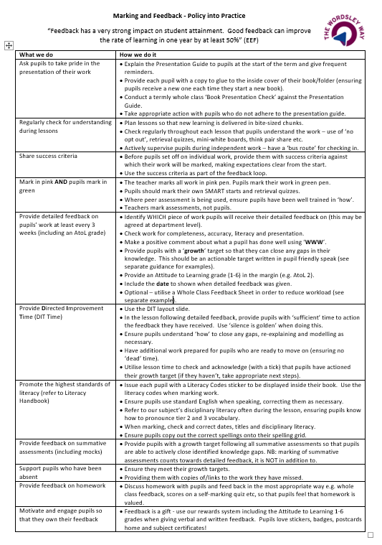

Appendix 2

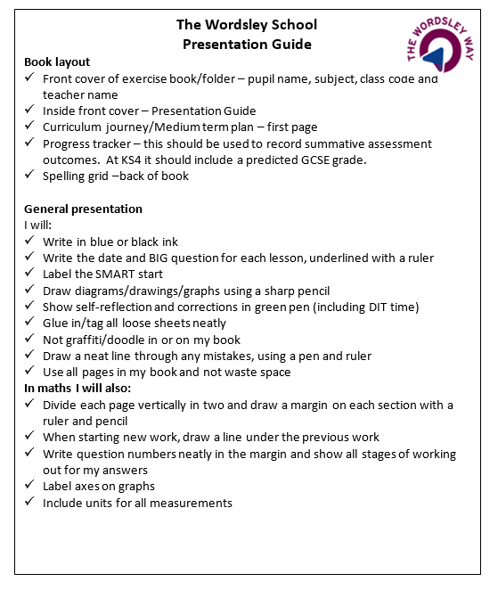

Appendix 3

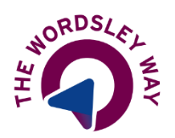
Marking and Feedback – examples of WWW and Growth Targets
In our feedback to pupils we need to be specific about what pupils have done well (WWW) i.e. their strengths, and how they can get even better i.e. their Growth Target. To ensure everyone has clarity on what these should look like, a number of examples have been provided below.
Subject | WWW | Growth Target
Maths | Expanding double brackets. | Collect like terms to simplify the expression.
Technology | You have created a range of ideas showing what you want to make. They have been drawn accurately and are clear. Well done! | In order to achieve the next colour, annotate (label) your ideas with information regarding materials, manufacturing processes, target market requirements and any environmental issues (see writing frame for guidance).
Food | You have successfully identified the different hazards and stated their consequences. Well done! | In order to make further progress, define the term ‘food poisoning’ and identify a cause of food poisoning.
Art | You have described the artist’s work in detail including the subject matter, colour, technique and style. Well done! | In order to achieve the next colour, relate the work of the artist to the relevant art movement and explain why.
Business | You have used the PBLTA framework to put together a logical answer.  You have considered the impact upon the target market of the business. | Read through your answer and insert 2 appropriate business key words into your paragraph.  Explain how a different group of stakeholders would be affected by the business’ decision to grow.
English | You have used a range of language techniques within your writing.  You have provided detailed analysis of your quotations. | Include a range of persuasive language techniques in your writing including a fact, statistic and a rhetorical question.  Ensure you explore the quotation - give an alternative piece of analysis for the quotation.
MFL | You have understood the main points of the text. (Listening or Reading).  Your spelling is mostly accurate and would be understood by a native speaker. (Writing).  You are making good progress with your translation skills.  You have used appropriate tenses.  You have applied the grammar rules effectively. | 1) Using your notes how would you say the following in Spanish (or English)/translate the following into Spanish (or English).  2) Read your notes, apply the grammar rules and correct the (following) sentence.  3) Answer the following question in Spanish and translate it into English.  4) What connectives could you add to improve your writing.  5) Learn to conjugate the verb ‘tener’ in the present tense.

Appendix 4

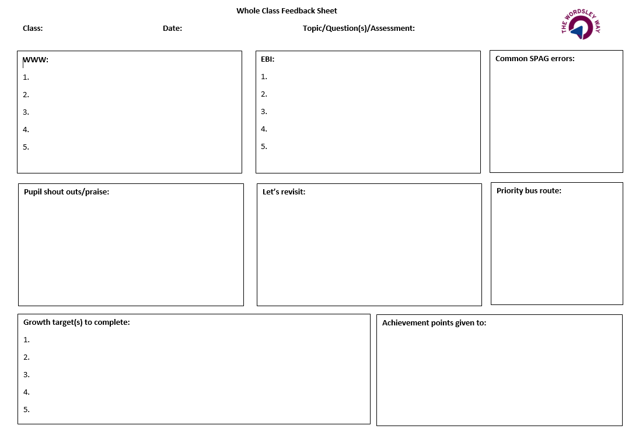

Appendix 5

